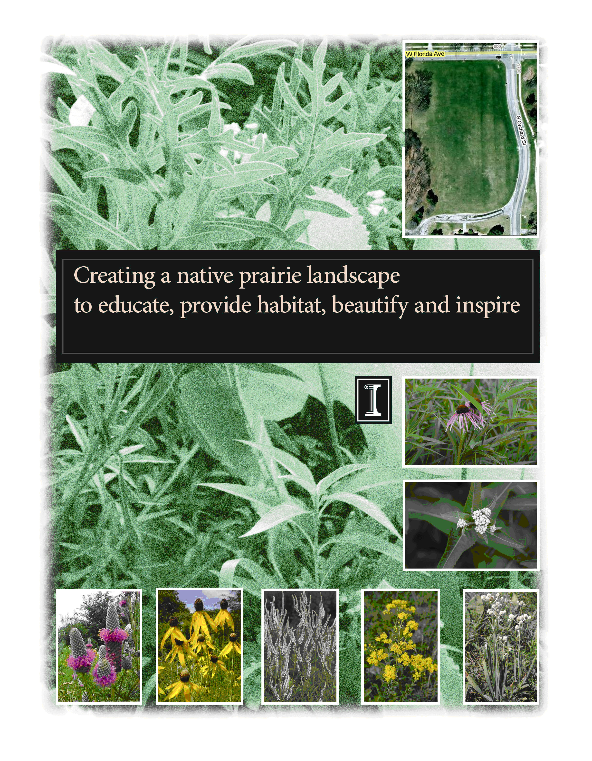
Applicant Information
Project Lead Contact Information
Name: Anton G. Endress Name: James Ellis
E-Mail: aendress@illinois.edu E-Mail: jamese@inhs.uiuc.edu
Title: Professor, Department of Natural Title: Botanist, Illinois Natural History Survey
Natural Resources & Environmental Sciences President, Grand Prairie Friends
Phone: (217) 244-1679 Phone (217) 244-5695
Address: 34 National Soybean Research Address: 1816 Oak St., MC-652
Center, MC-637
UIUC and Community Partners
Facilities and Services
Office of Sustainability Grand Prairie Friends of Illinois
Fire Service Institute Master Naturalist Program
Student Sustainability Committee Red Bison
Champaign County Forest Preserve District Students for Environmental Concerns
Urbana Park District Wildlife Society (UIUC Student Chapter)
Private Donor

A 2005 report from The Sustainable Campus Landscape Subcommittee describes the Guiding Vision for landscaping on the University of Illinois campus:
“The campus landscape plan should develop a sense of pride with native ecosystems of Illinois, the Prairie State, that fosters both an awareness of prairie vegetation and an understanding of ecological processes that led to its development. The campus landscape should project a patchwork of native plants that collectively represent a vignette of the natural heritage of the Illinois Grand Prairie. The experience of a walk through campus should engage the university community to appreciate its locality in east central Illinois. Along with its capacity to beautify, educate, and inspire, an additional benefit will be decreased maintenance requirements that render a more sustainable campus in the long run.”

The no-mow zone at the southwest corner of Florida Ave. and Orchard St. is an ideal location to implement the campus’ first large prairie planting and thereby respond assertively to the campus vision. It will provide a site for an array of learning and passive recreation opportunities for both students and members of the extended community, while sequestering greenhouse gases as tangible evidence of the campus commitment to responsible sustainable behavior.

I. Project Description
Background
Illinois is the Prairie State, so-called because of the once biologically rich grassland that covered about 60% of its landscape. Today, because of agricultural and urban development, more than 99% of the original prairie is gone. Efforts to conserve the state’s prairie heritage include protection of unplowed remnants, reconstruction of prairie through new plantings and creation of gardens using native prairie plants.

Prairie restorations are frequently justified on ecological grounds by the extent to which they enhance biodiversity or contribute to recovery of a nearly extinct ecosystem type or on economic grounds by their reduced maintenance needs for labor, energy, and chemicals. An often overlooked benefit is the sustainability benefit, their capacity to store CO₂ and thus contribute to the reduction of global warming (Table 1).

Table 1. Productivity of selected biomes per day and per unit leaf area.

Biome | Daily NPP  per ground area  (g m⁻² d⁻¹) | Total LAI  (m² m⁻²) | Daily NPP  per leaf area  (g m⁻² d⁻¹)
Tropical forests | 6.8 | 6.0 | 1.14
Temperate forests | 6.2 | 6.0 | 1.03
Tropical savannas & grasslands | 5.4 | 5.0 | 1.08
Temperate grasslands | 5.0 | 3.5 | 1.43
Deserts | 2.5 | 1.0 | 1.80
Crops | 3.1 | 4.0 | 0.76

Vision and Scope of Work
We propose to install a prairie planting comprised of plant species characteristic of native tallgrass prairie in east-central Illinois. The area suggested for this prairie restoration is the current No-Mow Zone on the southwest corner of the intersection of Florida Ave. and Orchard St. This restoration is designed to educate, beautify, and inspire. It will serve as a highly visible public symbol of our commitments to (1) the historic ecological legacy and the native species once found in this complex ecosystem and (2) campus-wide efforts toward sustainability and carbon neutral practices. The resulting prairie planting will increase native biodiversity, improve soil quality, capture and fix carbon into the earth, kindle interest in protecting remnant prairies, promote prairie plantings, and provide an educational experience for the community, while simultaneously reducing the expenses associated with maintaining the more labor- and energy-intensive turfed landscapes.

Restoration Approach
Prairie restorations typically follow one of two pathways. In the first (often termed interseeding), seeds are drilled or broadcast over existing vegetation, but without cultivation. The site may either be burned or treated with herbicide prior to planting. In the second approach, prairie seeds are planted in a weed-free seedbed that has been carefully cultivated, herbicided, or both. Each approach has advantages and disadvantages, and there are situations in which one is more appropriate than the other. For the Florida-Orchard site, we recommend the interseeding approach for the following reasons:
- Less time and energy (and hence cost) required for site preparation (cultivation),
- Reduced potential for soil erosion, and
- Lower risk of invasion by non-indigenous vegetation.
After seeding, the site itself will determine which species will be most successful in particular locations. As the prairie establishes during the first winter and spring, designs for a small interpretive garden to best utilize the site for education and visitation purposes will be solicited from restoration firms with landscape architects. The resulting focal interpretive garden, a ‘contrived’ prairie if you will, can showcase species in a particular interplay of color, form, and texture to facilitate public education concerning the distinctive grassland ecosystem.
Plan of Work
The proposed work site is shown in Figure 1. Based on plans from the Facilities and Services Planning Division, the proposed planting site is approximately 117,000 ft² (approximately 2.7 acres). Allowing for mown grass or bark pathways and focal interpretive areas, the actual prairie restoration will be slightly smaller. Our budget includes a prairie seed mix sufficient for seeding 2.5 acres plus transplant plugs for an interpretive area.
- Site Preparation & Planting – There are two basic ways to plant a prairie: hand seeding or machine seeding. Machine seeding is more effective because it requires less seed, can be employed on non-cultivated fields, and the seed drill does a better job of placing the seed at the correct seeding depth, thus ensuring more uniform germination of seed. We expect to utilize the no-till seed drill owned jointly by the Urbana Park District and Champaign County Forest Preserve District.
Preparation of the planting site will begin in early August with an initial mowing followed by removal of the clippings and application of a general glyphosate-based herbicide to kill the sod. A licensed contractor or qualified partner agency will be employed to apply the herbicide. Two herbicide applications may be necessary to ensure a weed-free planting bed. The prairie will be machine seeded in November. It is likely that two of the projects partners, the Champaign County Forest Preserve District and Urbana Park District, will do the planting on our behalf; otherwise a commercial contractor will be engaged for this purpose.
The site contains recently planted saplings of various tree species. The oak seedlings will be retained on the site, however seedlings of the other species should be transplanted elsewhere. Transplanting the trees may require a tree spade. Responsibility for the decision to transplant or cull trees from the site lies within Facilities and Services, and should be made prior to herbicide application. The herbicide applicator will exercise appropriate caution to ensure the oaks are not harmed.
Several factors recommend planting this fall rather than next spring: (a) Greater availability of seed, (b) Rate of forb seed germination is generally higher in the fall compared to the spring, (c) No need to stratify the seeds prior to planting, (d) Implementation can take advantage of academic schedules and availability of student interns and volunteers, and (e) Funding availability and donor interest. Planting the site is expected to occur after the first frost – mostly likely in November.

- Seed Mix – We propose to use a prairie seed mix (Table 2) containing about 60 species (roughly 60-65% forbs by weight) in order to facilitate a showy, species-rich community in which grasses do not become overly abundant. Seeding rates of 40-60 seeds per square foot generally yield good results. This is roughly 250,000 seeds per acre.

Prairie species characteristics, such as height, flowering time, and flower color, were considered for inclusion in the mix. The mix contains seeds of species that germinate quickly and easily re-seed themselves under good conditions. Such reliable species
can be interplanted with other species once the prairie becomes established. The seed mix includes warm-season grasses and highly adaptable forbs, such as wild bergamot, grey-headed coneflower, black-eyed Susan, pale purple coneflower, and some legumes.
Table 2. List of plant species for the no-mow prairie restoration project.

Scientific Name | Common Name | Scientific Name | Common Name
Amorpha canescens | Leadplant | Lilium michiganense | Michigan lily
Andropogon gerardii | Big bluestem | Lobelia spicata | Spiked lobelia
Anemone cylindrica | Thimbleweed | Monarda fistulosa | Wild bergamot
Asclepias sullivantii | Sullivant’s milkweed | Panicum virgatum | Switch grass
Asclepias tuberosa | Orange butterfly weed | Parthenium integrifolium | Wild quinine
Aster ericoides | Heath aster | Penstemon digitalis | Foxglove beardtongue
Aster laevis | Smooth aster | Petalostemum purpurea | Purple prairie clover
Aster novae-angliae | New England aster | Phlox pilosa | Prairie phlox
Aster oolentangiensis (azureus) | Sky blue aster | Potentilla arguta | Prairie cinquefoil
Baptisia alba | White wild indigo | Pycnanthemum virginianum | Common mountain mint
Baptisia leucophea | Cream wild indigo | Ratibida pinnata | Grey-headed coneflower
Boutelua curtipendula | Side-oats grama | Rudbeckia hirta | Black-eyed Susan
Cassia fasiculata | Partridge pea | Rudbeckia subtomentosa | Brown-eyed Susan
Ceonothus americanus | New Jersey tea | Ruellia humulis | Prairie petunia
Coreopsis palmata | Prairie coreopsis | Schizachyrium scoparium | Little bluestem
Coreopsis tripteris | Tall coreopsis | Silene regia | Royal catchfly
Desmodium canadense | Showy tick trefoil | Silphium integrifolium | Rosin weed
Desmodium illinoense | Illinois tick trefoil | Silphium laciniatum | Compass plant
Dodecatheon meadia | Shooting star | Silphium perfoliatum | Cup-plant
Echinacea pallida | Pale purple coneflower | Silphium terebinthinaceum | Prairie dock
Echinacea purpurea | Purple coneflower | Solidago rigida | Stiff goldenrod
Elymus canadensis | Canada wild rye | Sorghastrum nutans | Indian grass
Eryngium yuccifolium | Rattlesnake master | Spartina pectinata | Prairie cord grass
Gentiana andrewsii | Bottle gentian | Sporobolus heterolepis | Prairie dropseed
Gentiana puberula | Downy gentian | Tradescantia ohiensis | Ohio spiderwort
Heliopsis helianthoides | False sunflower | Verbena stricta | Hoary vervain
Heuchera richardsonii | Prairie alumroot
Lespedeza capitata | Round-headed bushclover | Vernonia fasiculata | Common ironweed
Liatris aspera | Rough blazing star | Veronicastrum virginicum | Culver’s root
Liatris pycnostachya | Blazing star | Zizia aurea | Golden Alexanders

Many species will overwinter in the soil and germinate the second year, while others may not germinate until environmental conditions are just right – sometimes not for three or four years. This is especially true for shooting star, Culver’s root, alumroot, gentians, and others. These species will be hand-broadcast during the late fall of the second through fourth years.
The seeds will be procured commercially from vendors who supply product on a pure live seed basis. This is a numerical value obtained by testing the seed of each species for purity and germinability. Not only does this ensure the acquisition of quality seed, but also avoids purchasing more seed than is required. In subsequent years, collecting seeds from local sites to augment our planting is likely.

- Interpretive Garden – During the period May-June 2010, the interpretive area will be organized and planted according to the selected commercial design. Rather than use seeds, the interpretive area will utilize plugs, individual small container-grown seedlings, purchased from commercial native plant nurseries. The plugs will be installed at one and two foot spacing intervals to allow adequate room for future growth. Drill-mounted augers will be used to bore the small holes in which the plugs will be inserted. All plugs will be thoroughly watered immediately following planting. The entire process of planting, watering, and mulching should take two to three days depending on the size and availability of a planting crew.
- Initial Maintenance – The seeded prairie will be checked periodically for unwanted weeds during the first season. Typically a new prairie planting might need mowing once or twice during the growing season to prevent weeds from setting seed. The interpretive area will also require timely watering to ensure survival of seedlings. Unwanted weeds will be pulled or treated with herbicide as needed.

Long-term Management
1. Prescribed Burns -- Management of the vegetation will require prescribed burning. The frequency of burning required and the timing of burns will depend on the rate and extent of woody invasion, the need for control of non-indigenous species, and the rate of fuel accumulation. New restorations are generally burned frequently during the first five years or so. Historically, the tallgrass prairies of Illinois burned every two to four years.

The timing of prescribed burns is flexible. Late summer fires were frequent throughout the tallgrass prairie region as a result of lightning strikes, fall burning was customary for the Native Americans in this area, and many habitat managers have made prescribed burning a spring rite. Since spring and fall burns each favor different plant species, the wisest course of action is to avoid repeated burns at one particular season and instead to burn at various times of the year.

It is also not wise to burn the entire site at once to avoid high mortality of insects and other small invertebrates in the litter. We propose using mowed trails to subdivide the site into three (preferably) burn units. Each year, one of the units is not burned in order to provide a refuge from the fire for these creatures.

We propose engaging the Fire Services Institute and experienced habitat managers from local organizations as active partners in the burn management program. Developing the necessary expertise within Facilities and Services is an essential first step as the campus moves increasingly toward native plantings.

Familiarity with permit acquisition and the development of desirable and effective practices to notify residents about upcoming burns and facilitate community buy-in are equally important.

However, dormant mowing in late winter/early spring will help the plants as well, both forbs and warm season grasses. If burning will be a problem on campus (liability or smoke difficulties) the backup option will be dormant mowing combined with removing the mowed material. A "chicken picker implement on a tractor could be used to row it and followed by picking it up with an alfalfa bailer. Mowing and removal of the dead plant material will provide a disturbance and duff removal mechanism that can be nearly as beneficial as a burn regime
2. Invasion Patrol –– Control of non-indigenous species requires vigilance and persistence. Site stewards, frequently student or community volunteers, will be essential in checking the restoration site for unwelcome arrivals of new species and taking prompt action when they are detected. The first discovery of an invasive species may be appropriately controlled by straightforward mechanical means. The penalty for not scouting or for not reacting promptly may be severe, requiring significant labor or pesticide investments.
3. Species Enrichment -- The number of native species present is often one of the criteria for measuring the success of a restoration. Diversity of the restoration tends to increase in the early years for two reasons: (a) seeds of additional species are often broadcast during the winter months and (b) some seeds germinate more slowly than others and thus species richness increases across time.
4. People Management -- The site will require people management in the long-term. This may be a challenge, but the opportunity to encourage visitors to enjoy and learn about these complex ecosystems, or to provide hands-on learning experiences for our students, overshadows many potential difficulties. The following approaches will be helpful:

- Utilizing the site for student education (an on-campus internship) is expected to develop a corps of knowledgeable student site stewards who may facilitate site management and community education.
- Engaging the assistance of Red Bison, Students for Environmental Concerns, Master Naturalists, Grand Prairie Friends, and other local groups in establishing a volunteer program. Recruited volunteers may provide labor, but their most important contribution is as a core of informed and enthusiastic activists who will spread the word about native plantings.
- Educating the public. Whether communicating within local neighborhoods about the value and scheduling of prescribed burns, offering talks or tours, or preparation of printed materials for newspapers and newsletters, volunteers will be valuable University partners.
5. Monitoring and Record Keeping -- Maintaining a written record of observations and management activities is important in order for future management to be informed by the past – avoid repeating mistakes, evaluating effects of management, plan future management based on the record. Collecting data in a systematic way will be necessary to follow long-term changes. Consequently we expect to initiate discussion with faculty colleagues to include the Florida-Orchard site as part of the sampling activities in the courses they teach.

II. Budget

The proposed budget is conservative. The actual costs are likely to be less, but cannot be confirmed at this time. The amount of available funds is also significantly greater than the estimated project cost.
Estimated Project Cost

Herbicide Applications $ 2,000
First Year Seeds $10,000
Future Seeds $ 5,000
Interpretive Area (plugs, mulch, etc.) $15,000
Cover Crop $ 1,000
Landscape Architect/Other Labor $ 5,000
Total Cost $38,000

Available Funding

Student Sustainability Committee $ 40,000
Private Donation $ 10,000
Total Available $ 50,000
Future maintenance costs at or below current practices will be supported by Facilities and Services (i.e. mowing). Additional maintenance costs will be supported by volunteer labor and additional project funding raised through the sustainable landscape endowment or Student Sustainability Committee.
At the request of Facilities and Services, the Student Sustainability Committee agrees to cover the cost of restoring the location to grass should the project be unsuccessful.
III. Timeline
August 2009 Information meetings with neighborhood residents, interested parties Mow site, remove clippings, apply herbicide
Finalize seed mix, order seeds
September 2009 Solicit designs for interpretive areas

October 2009 Scout for weeds; re-apply herbicide if needed

November 2009 Machine seed the site with prairie seed mix
Scout for weeds
Assess for irrigation

December 2009 Select interpretive area design, order plugs
Assess need for species enrichment via hand-broadcast
Determine educational text, design and order signage

May- June 2010 Prepare and plant interpretive area
Mow site to 8-10 inch height
IV. Environmental Impact
Sequestration of CO2 and cessation of mowing long-term provide beneficial environmental impacts compared to the mown turf previously present at the site. Additional benefits accrue from increased biodiversity and improvement of soil quality. This project is most appropriately understood as an early step in the larger effort of converting the campus toward more responsible landscaping.
V. Outreach Education
Through signage on-site, as well as through opportunities to participate in caring for the prairie, faculty, staff, students, and the general public can learn about the plants and the importance of native prairie. Staff from the Illinois Natural History Survey can direct these educational efforts.
We would also invite local media to key events related to the creation and maintenance of his new garden in an effort to elevate awareness of the campus sustainability initiative.

VI. Bibliography

Chapin III, F.S., Matson, P.A., and H.A. Mooney. 2002. Principles of Terrestrial Ecosystem Ecology. Springer Science+Business Media, New York, USA.

Gower, S.T. 2002. Productivity of terrestrial ecosystems. Pages 516-521 in H.A. Mooney and J. Canadell, editors. Encyclopedia of Global Change. Vol. 2. Blackwell Scientific, Oxford, UK.

Calculated from Table 6.3 in Chapin et al. (2002). NPP is expressed in units of dry mass.
Net Primary Production (NPP) is the net carbon gain by vegetation resulting from the balance between carbon gained from photosynthesis and that lost by normal metabolism.
Data from Gower (2002)

