SSLC minutes

April Meeting (4/11/2014)

Presentations: Global Environmental Brigades and USGBC (UIUC chapter)

**Global Environmental Brigades at UIUC**

Structure

Global Brigades

* 9 programs
  + Medical
  + Dental
  + Public Health
  + Water
  + Architecture
  + Business
  + **Environmental**
  + Human Rights
  + Microfinance
* MANY chapters
  + Global Brigades is the largest student-led global health and sustainable development organization
  + UIUC representatives here
* Global Brigades’ **Mission:** To empower volunteers to facilitate sustainable solutions in under resourced communities
* Global Brigades’ **Vision**: To improve equality of life, by igniting the largest student-led social responsibility movement on the planet.

Where we go

* GB goes to under resourced communities in Nicaragua, Panama, Ghana, and Honduras
  + Environmental programs only offered in Panama
  + Need in Panama
    - Panama loses more than 1% primary cover each year
    - Degrading cattle ranching and logging
    - Slash and burn
* Communities chosen based on
  + Environmental need
  + Community Commitment
  + Land availability for projects

What does a brigade look like?

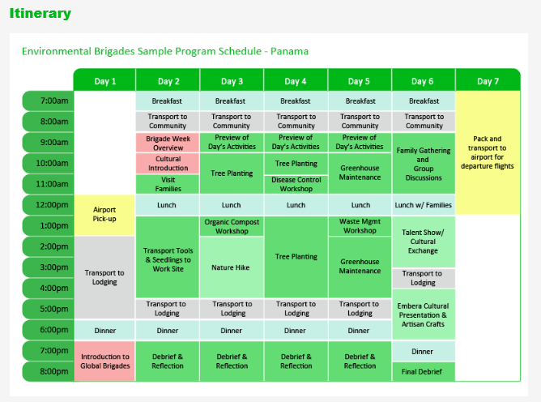

Video from last year’s brigade <http://www.youtube.com/watch?v=6Aekhz8LHnQ>

Upcoming events

* Glow the distance 5k
  + May 3rd, 2014
  + Main Quad, 9p
* Environmental Group Social Event
  + April 23rd, 2014
  + 9p
* General Meetings
  + Thursdays @7p, Greg 311

Contact info: [gebuiuc@gmail.com](mailto:gebuiuc@gmail.com)

**USGBC – UIUC chapter**

US Green Building Council

What we’ve done

* Meetings
  + Speaker presentations
  + Teaching staff presentations
* Projects committee
  + “Green your dorm” (at LAR)
  + Green Building Conference and expo
  + Student Sustainability Symposium
    - Student group speakers
    - Table talks
    - Professor speakers

**EARTH WEEK**

<http://sustainability.illinois.edu/earthweek2014.html>

**iCAP forum –** Ben McCall

- got first draft for “no net increase in space” group

*Tentative* SWATeam process:

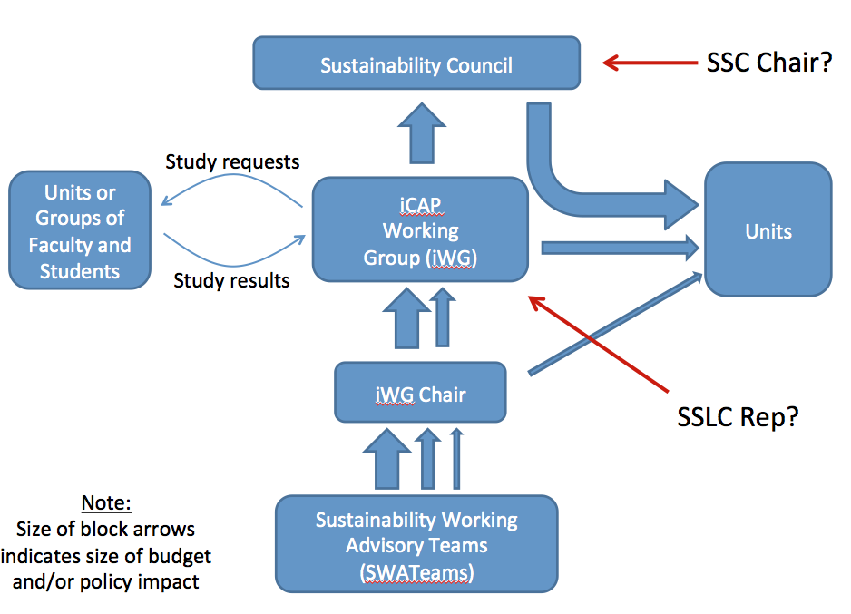

1. SWATeams will group requests into small, medium, and large requests and send to the iWG chair.
2. If iWG chair agrees that small requests should be implemented, it will be “okay-ed”. Medium and large requests are sent to iCAP working group for discussion.
   1. Hope that a student would be represented in the iWG, chosen from SSLC
3. iCAP working group “okays” certain medium requests and passes *feasible* large requests to the Sustainability Council.
   1. Sustainability Council = chancellor, vice chancellor for research, senate, provost
      1. Maybe add SSC chair to this group?

Topics for discussion

1. Public minutes?
   1. SSLC members at 4/11 meeting agreed that YES, we should have public minutes
2. Representation from groups
   1. SSLC/Ben need to know changes in leadership for next year
   2. Only ONE representative from each group should attend meetings from now on
3. Do we want a SSLC elected coordinator/chair?
   1. Responsibilities would include representing SSLC at iCAP working group, organizing meetings (possibly with the help of IC inter)
   2. SSLC members at 4/11 meeting agreed that YES, we should
   3. SSLC coordinator selection process:
      1. General app for all students, specifically group members from organizations represented at SSLC
      2. 3-5 applicants will be selected by Ben
      3. These 3-5 students will give a short speech at SSLC meeting
      4. SSLC members elect one
4. SWATeam agenda for next year
   1. Phase out graduating SWATeam student members during calendar year
   2. Consultation group will have periodic (maybe monthly or less) meetings with SWATeams
   3. Public forums will happen 1-2 times/semester